**Bootstrap Examples**

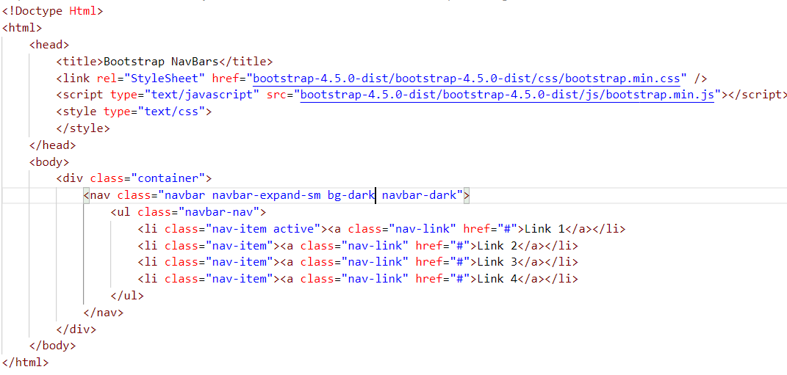

NavBar Example 1:

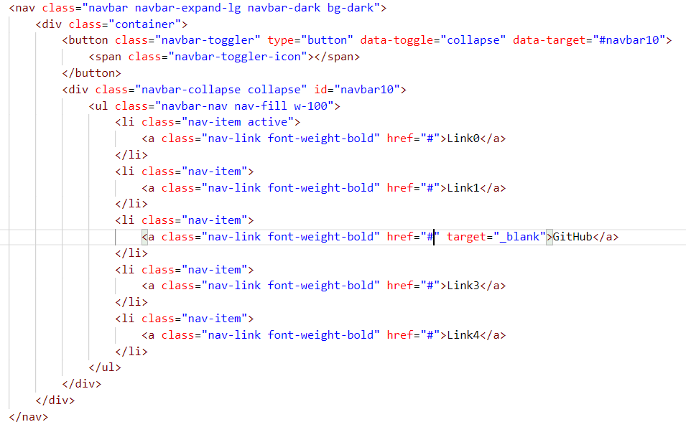

NavBar Example 2:

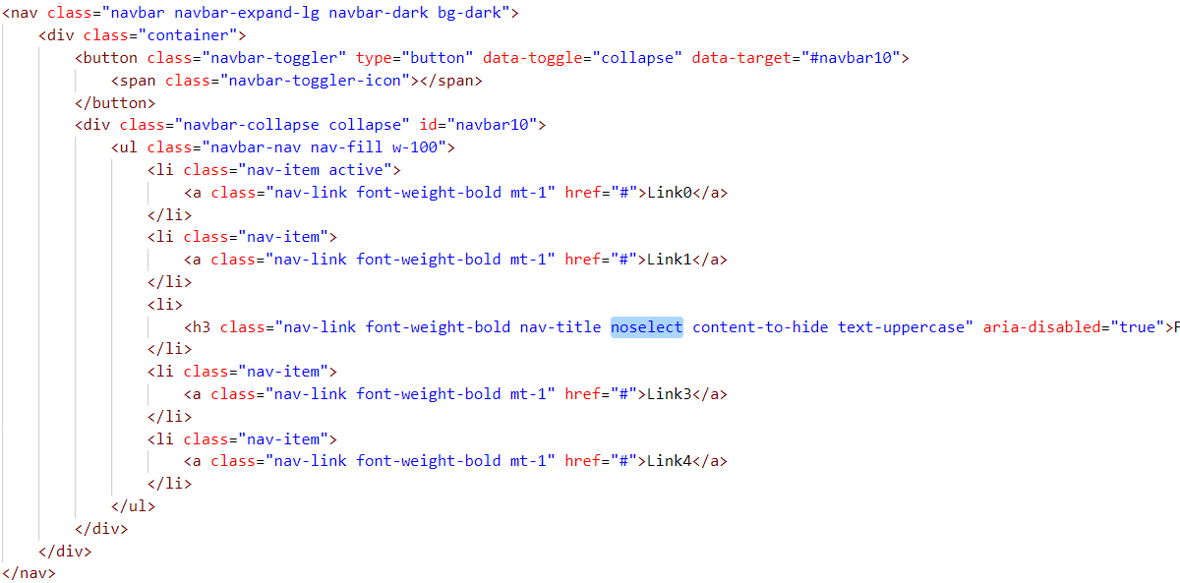

NavBar fixed:

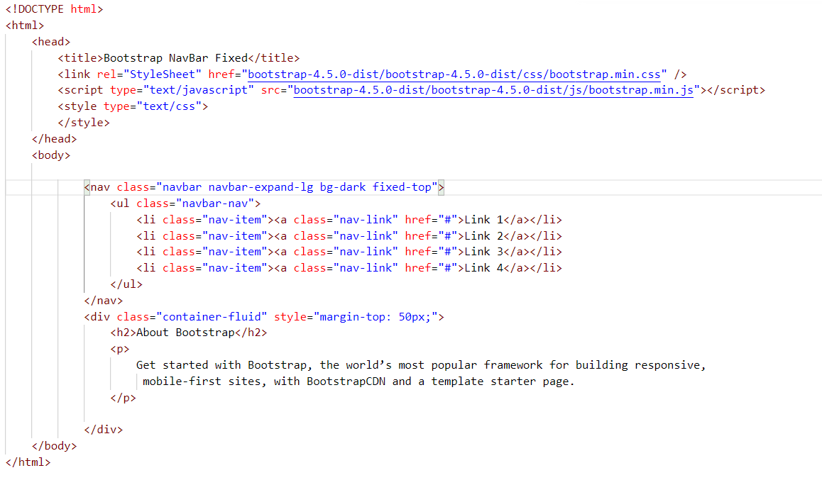

Modal Pop-Up

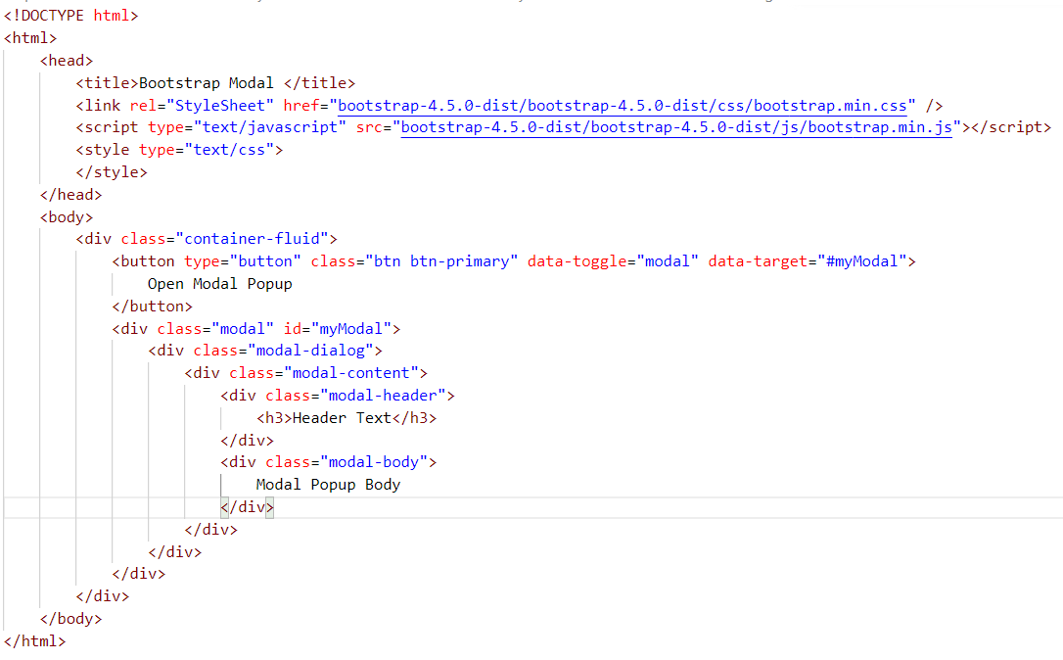

<!DOCTYPE html>

<html>

<head>

<title>Bootstrap Modal </title>

<link rel="stylesheet" href="https://maxcdn.bootstrapcdn.com/bootstrap/3.4.1/css/bootstrap.min.css">

<script src="https://ajax.googleapis.com/ajax/libs/jquery/3.5.1/jquery.min.js"></script>

<script src="https://maxcdn.bootstrapcdn.com/bootstrap/3.4.1/js/bootstrap.min.js"></script>

</head>

<body>

<div class="container-fluid">

<button type="button" class="btn btn-primary" data-toggle="modal" data-target="#myModal">

Open Modal Popup

</button>

<div class="modal" id="myModal">

<div class="modal-dialog">

<div class="modal-content">

<div class="modal-header">

<h3>Header Text</h3>

</div>

<div class="modal-body">

Modal Popup Body

</div>

</div>

</div>

</div>

</div>

</body>

</html>

Task:

Create a Button and When you click on the button it needs to open the Modal Popup as Simple Login Page